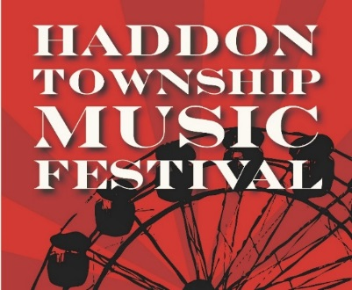
Sunday, October 15th, 2023
Vendor Application
The 8th Annual Haddon Township Music Festival will be held on Haddon Ave. from 1:00 pm to 9:00 pm. We have a full schedule of free entertainment, a beer garden, games, crafts and more! Space is available to all area artists, craftsman, civic organizations and businesses. All general rules apply to the Musical Festival. There is no Rain Date.
Booth spaces are 10’ deep by 10’ wide, outdoors. Spaces are reserved upon receipt of
reservation fee on a first come/first served basis. Each 10 x 10 space is $30 for the day.
All exhibitors are expected to follow all setup and breakdown instructions. Haddon Twp. reserves the right to deny any application. All food vendor must obtain a mobile vending permit from Camden County and all food trucks must obtain a fire permit from the Haddon Twp. Fire Prevention Bureau and contact Ryan Sheppard at rsheppard@haddontwp.com, prior to the event. NO EXCEPTIONS!
Sales tax collection and payment to the State of New Jersey is the exhibitor’s responsibility.
All checks should be made out to the Township of Haddon.
Contact Name:_________________________________________________________________________
Business Name:___________________________________________________________________
Address:______________________________________________________________________________
Phone:____________________________________Email:______________________________________
Detailed description of what you would sell at the event (include All products):
__________________________________________________________________________________________________________________________________________________________________________

HOLD HARMLESS CONTRACT AGREEMENT

I assume responsibility for my own booth space and agree to relieve the Township of Haddon of liability for any damages beyond due care, including claims for loss, damage, or injury. I understand I am responsible for insurance on my merchandise and equipment at my own expense. I understand this is to include public liability. I agree to abide by the General Rules set forth and assume responsibility for installing my booth space.
Print Name____________________________________________________________________
Signature_______________________________________ Date_______________________
Please mail completed application to:
Township of Haddon
135 Haddon Ave.
Haddon Township, NJ 08108

For more information contact:
Kate Burns at (856) 833-6267 or kburns@haddontwp.com
Amanda Rodriguez at haddonsquareevents@gmail.com

