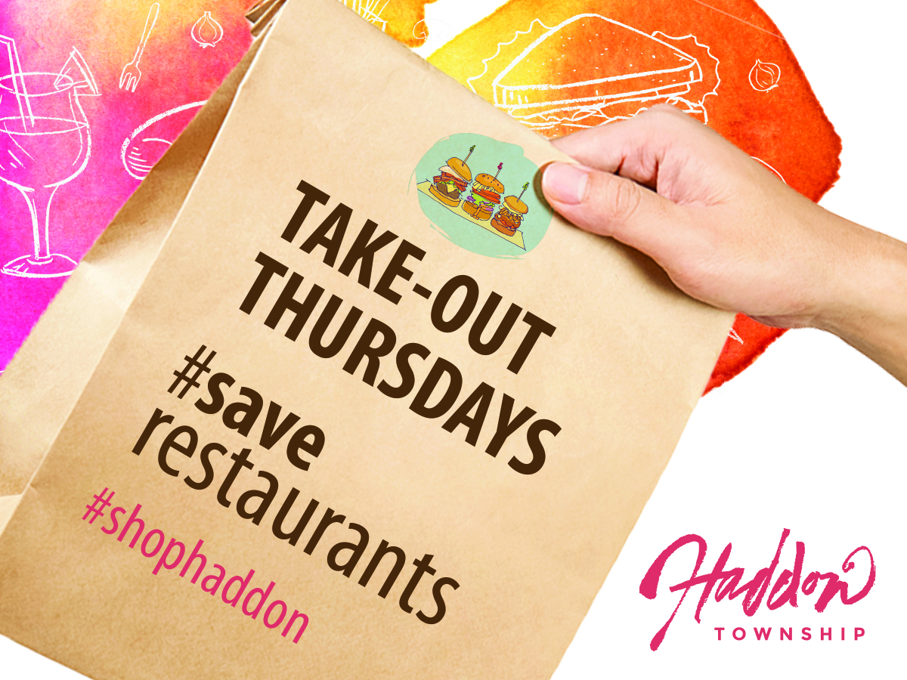

Haddon Township’s ‘Takeout Thursdays’ initiative promotes locally-owned
food/beverages establishments through the COVID-19 pandemic

FOR IMMEDIATE RELEASE

Contact:
Kate Burns, Business Improvement Liaison
Haddon Township
609-413-6528 (Cell)
kburns@haddontwp.com

Haddon Township Hosts ‘Takeout Thursdays’

Post a picture of your order to social media using the hashtag #ShopHaddon,
and enter for a chance to win a $100 gift card to your favorite Haddon Township restaurant

Haddon Township, NJ – June XX, 2020 – Haddon Township announces the ‘Takeout Thursdays’ initiative in order to help locally owned food/beverages establishments through the COVID-19 pandemic.

“We encourage everyone to support our locally-owned businesses and neighbors during these challenging times by participating in outdoor dining, taking part in curbside pick-up or delivery from our Haddon Township food/beverage establishments,” said Haddon Township Mayor Randall Teague.

When you order curbside pick-up or delivery from a Haddon Township food/beverage establishment, post a photo of your purchase, post to social media using the hashtag #ShopHaddon, and you will be entered to win a $100 gift card to your favorite Haddon Township restaurant.

A list of Haddon Townhip participating food/beverage establishments is available at www.ShopHaddon.com.

Voted as one of the top 20 towns to live, work, or play by South Jersey Magazine, Haddon Township has blossomed into one of the premier communities in the metro-Philadelphia region. Thanks to its prime location and dedication to community involvement, the roughly 14,000 residents of Haddon Township enjoy the perfect balance of work and recreation. With its proximity to the revitalized business district along Haddon Avenue and strong public art partnerships with the Ritz Theatre Company and SoHa Arts on the White Horse Pike, visitors can enjoy fine eateries, established businesses, and family-friendly community entertainment within a short walk from public transportation.

The Haddon Township Business Improvement District (HTBID) is the management coporation for the township’s business district. The HTBID is dedicated to one important goal: promoting a more positive and prosperous climate in which to conduct business in our community. The HTBID prides itself on being the preferred source of information for new and existing businesses, a catalyst for marketing and event promotion, and a leading force in improving and revitalizing the downtown to the benefit of owners and residents alike.

For more information please visit, www.shophaddon.com or www.HaddonTwp.com.

###

