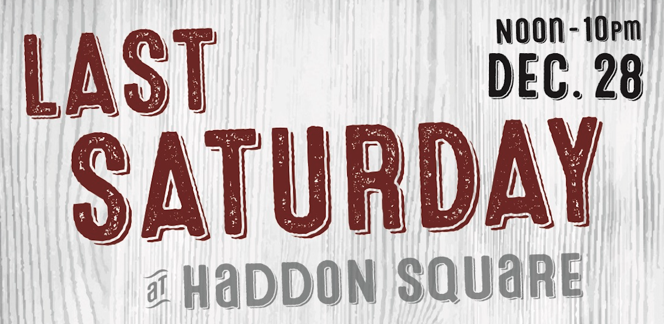

Haddon Township’s Annual ‘Last Saturday’ New Year’s Celebration
at Haddon Square takes place on Saturday, December 28

FOR IMMEDIATE RELEASE

Contact:
Kate Burns, Business Improvement Liaison
Haddon Township
609-413-6528 (Cell)
kburns@haddontwp.com

Haddon Township’s Annual ‘Last Saturday’ New Year’s Celebration
at Haddon Square Saturday, December 28

Haddon Township, NJ – November XX, 2019 – Celebrate the last Saturday of 2019 at Haddon Township’s annual ‘Last Saturday’ New Year’s Celebration at Haddon Square event on Saturday, December 28 from noon - 10 p.m.

Say goodbye to 2019 and hello to the new year with food, live music, warm drinks, outdoor firepits and much more.

Food will be provided by Just Forkit, and all-day music lineups include the Wayside Shake Up from 2-5 p.m. and The Rockets from 6 - 10p.m.

Haddon Township’s Last Saturday event also features a heated tent, sponsored by The Pour House, where guests can enjoy beer, cocktails, wine and more.

Haddon Township’s Last Saturday at Haddon Square is FREE to attend, and is family and pet-friendly.

For more information please visit www.haddontwp.com or www.shophaddon.com.

###

