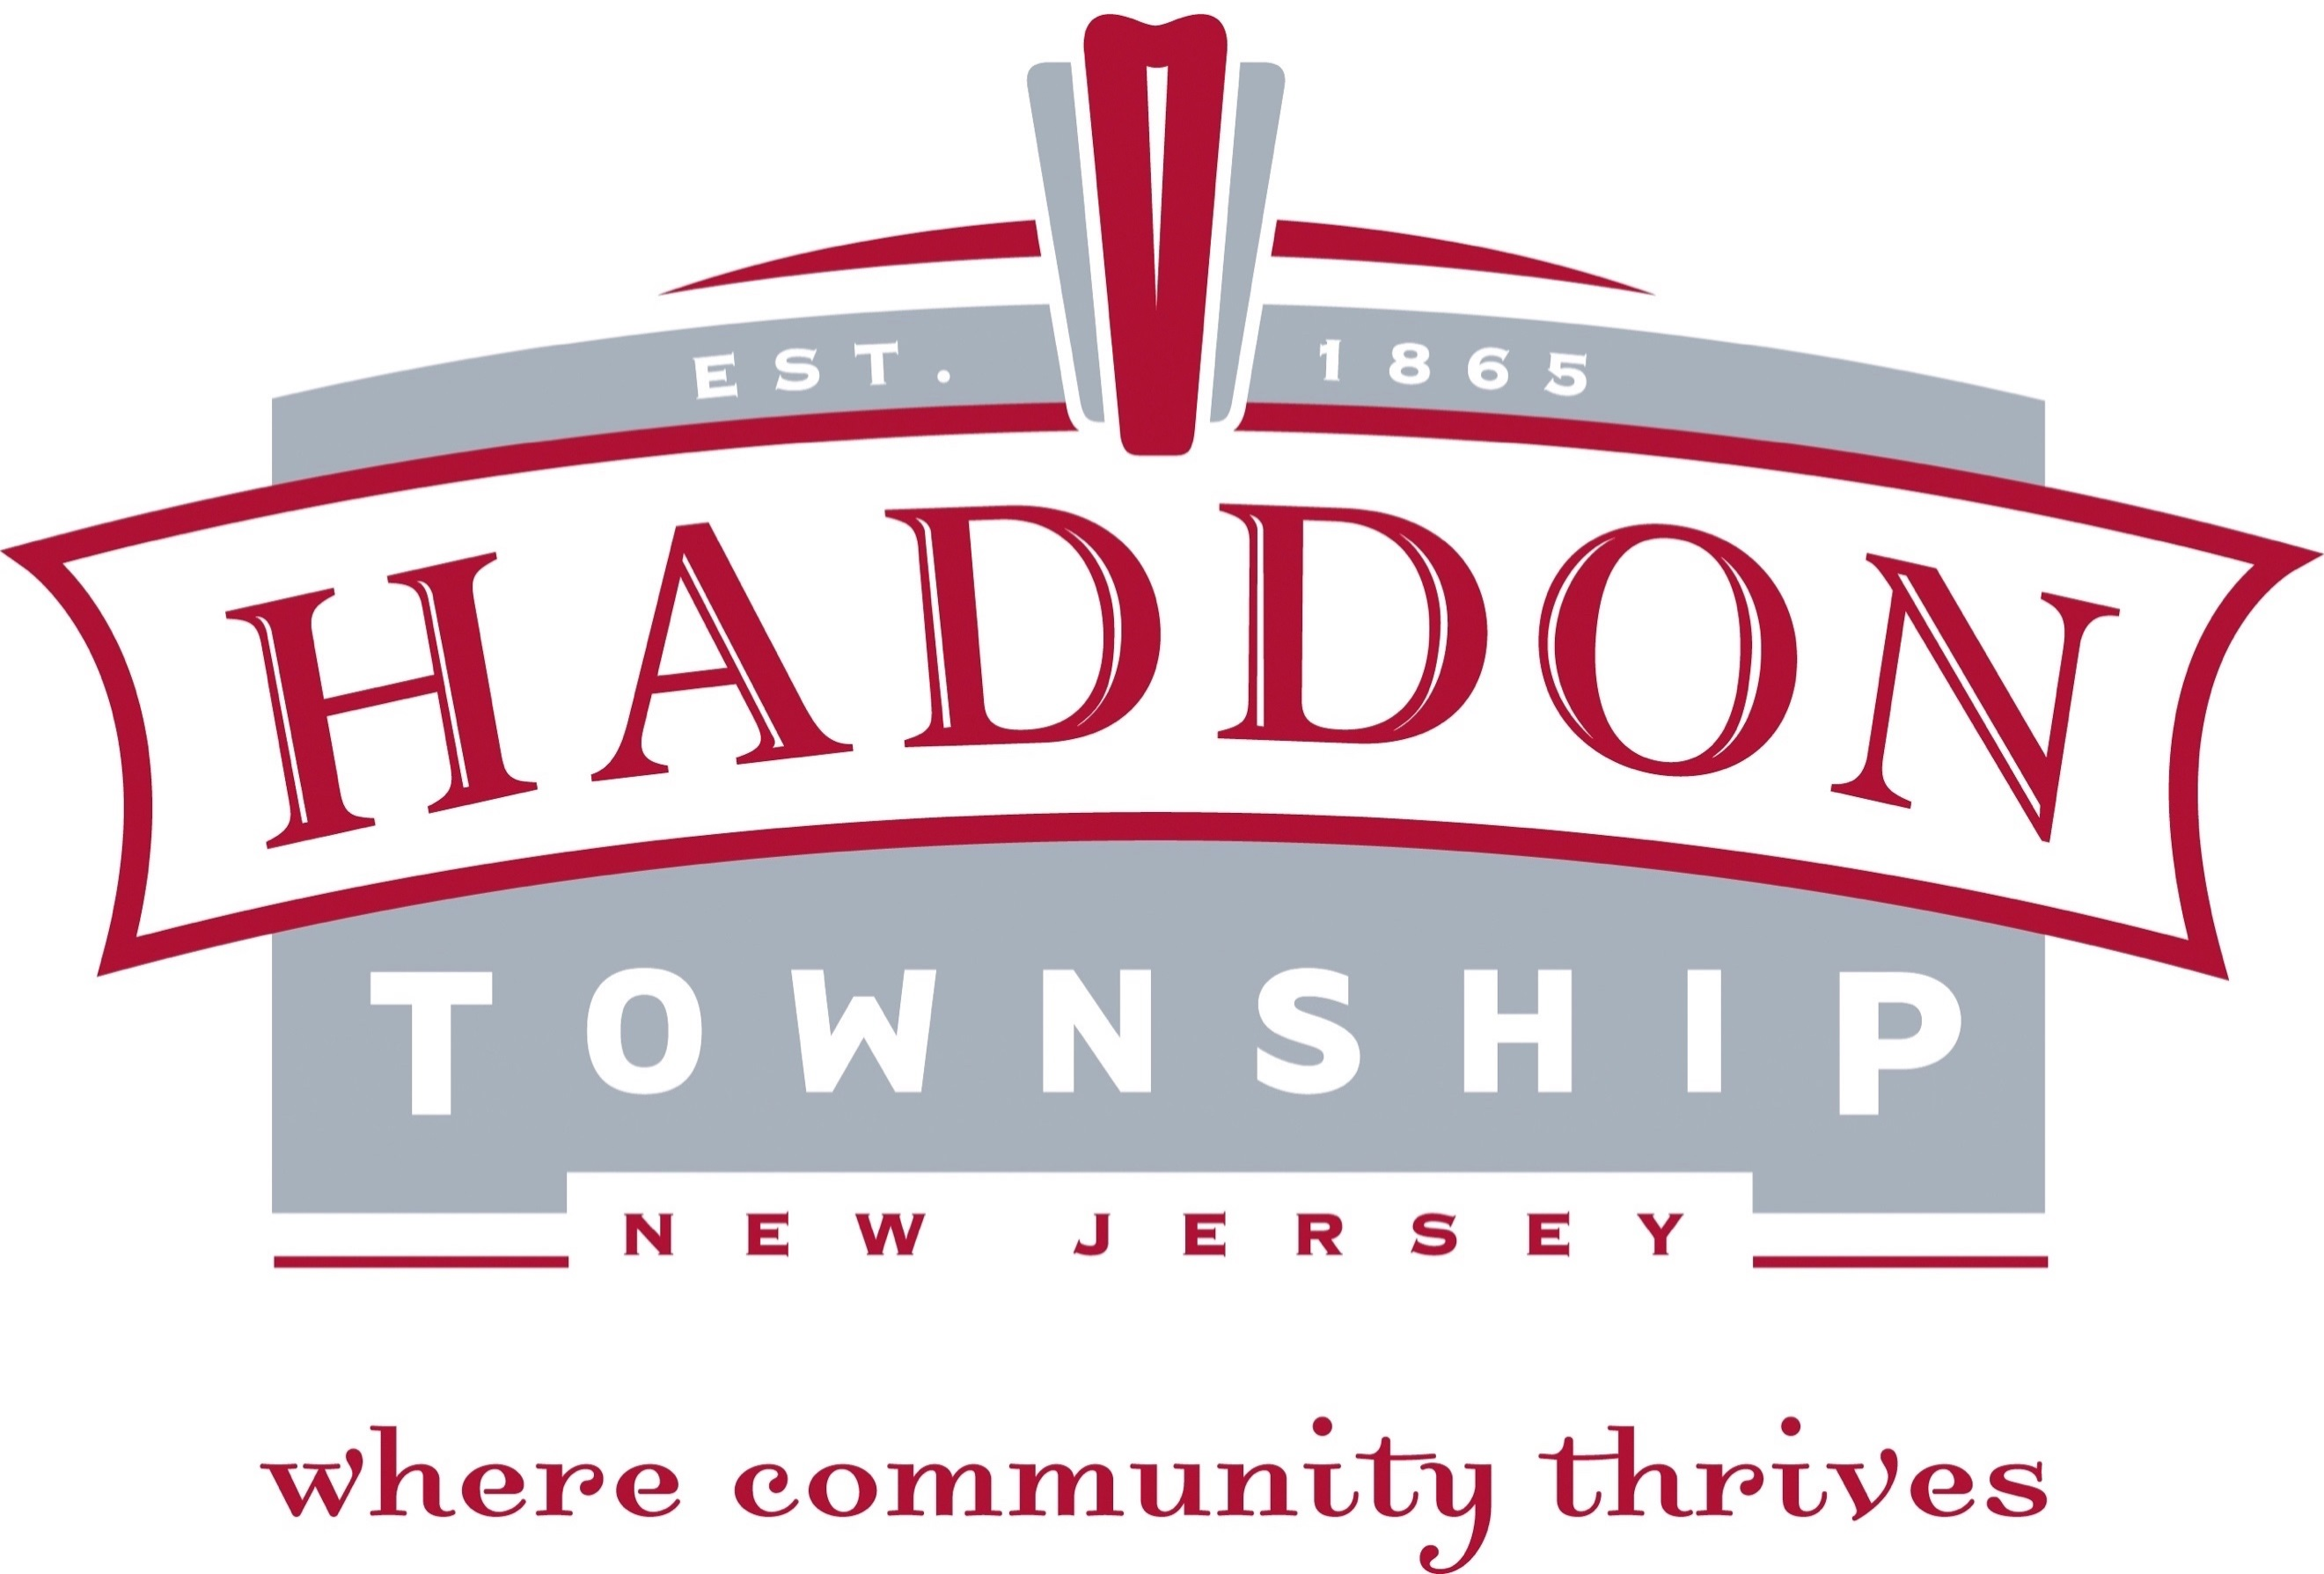

FOR IMMEDIATE RELEASE

Contact:
Kate Burns, Business Improvement Liaison
Haddon Township
609-413-6528 (Cell)
kburns@haddontwp.com

Haddon Township Announces Annual Holiday Toy & Food Drive
to Benefit Local Township Families

Haddon Township, NJ – November XX, 2019 –Haddon Township announced the launch of its annual Holiday Toy & Food Drive taking place now through Wednesday, December 18.

The 2019 Holiday Toy & Food drive is sponsored by Mayor Randall W. Teague, Commissioner Jim Mulroy and Commissioner Ryan Linhart to support local Haddon Township families in need.
Donations of unwrapped toys, non-perishable food items, gift certificates and monetary donations are being accepted. Donations may be made at the Haddon Township Municipal Building, Annex Building, Haddon Township schools and the Westmont Fire Company.

For more information on the Haddon Township Holiday Toy & Food Drive, please contact Kate Burns at 856-833-6267 or email at kburns@haddontwp.com.

For more information on Haddon Township please visit, www.shophaddon.com or www.HaddonTwp.com.

###

